**Agricultural Machinery Company**

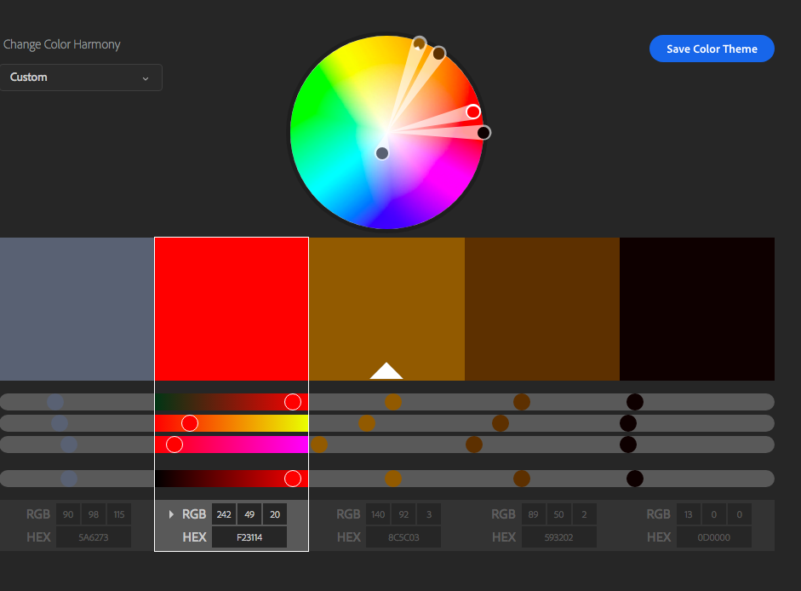

For the agricultural machinery company I chose gray and black because they represent strong pieces of machinery made of steel. I decided to include the deep red color to help my product stand out and be bright amongst mostly dull colors. The shades of brown are appealing to the consumer because they help to remind the buyer of fertile land and that is exactly what the buyer has in mind when looking for pieces of agriculture machinery.

**Baby Food**

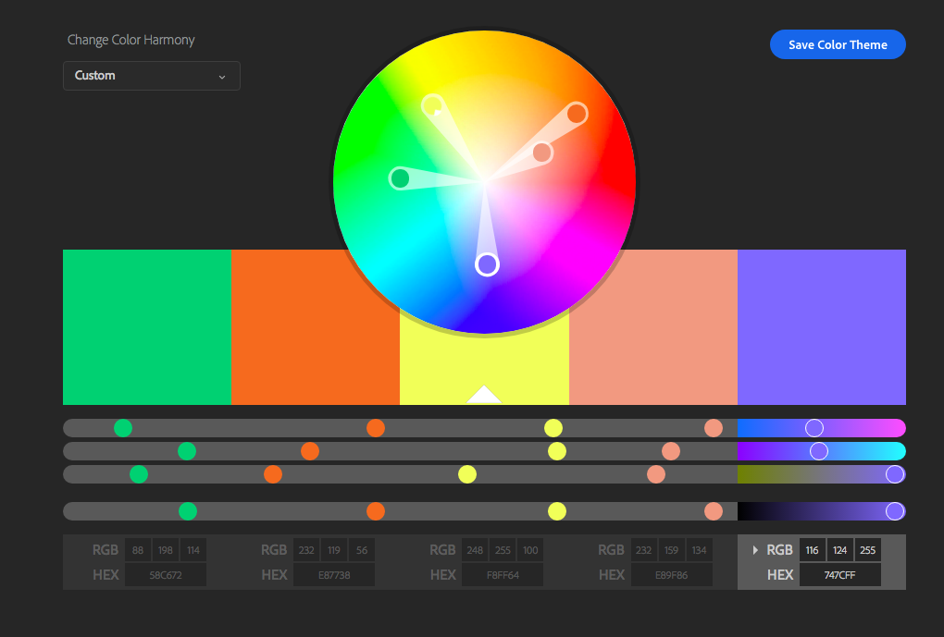

The colors I chose are mostly soft colors. I chose soft colors because I believe that the majority of the consumer base is going to be mothers in search of baby food and since women like soft colors more than men it fits the consumer base. These soft colors imply that the food is not spicy or harmful but rather mellow and safe for babies. The green and orange colors may remind the consumer of fruits and veggies. Since fruits and veggies are healthy it fits the product well. Lastly I chose the yellow because yellow makes people hungry and since this is a food product, I want the consumer to be hungry when looking at my product.